REPORT ON MICROSOFT AZURE FUNDAMENTALS

|  |  |
| --- | --- |
| Name | Sudarshan R |
| Register No | 710722104106 |
| Department | III B.E CSE |
| Date | 10.08.2024 |

# Sandbox:

Create a Linux virtual machine and install Nginx

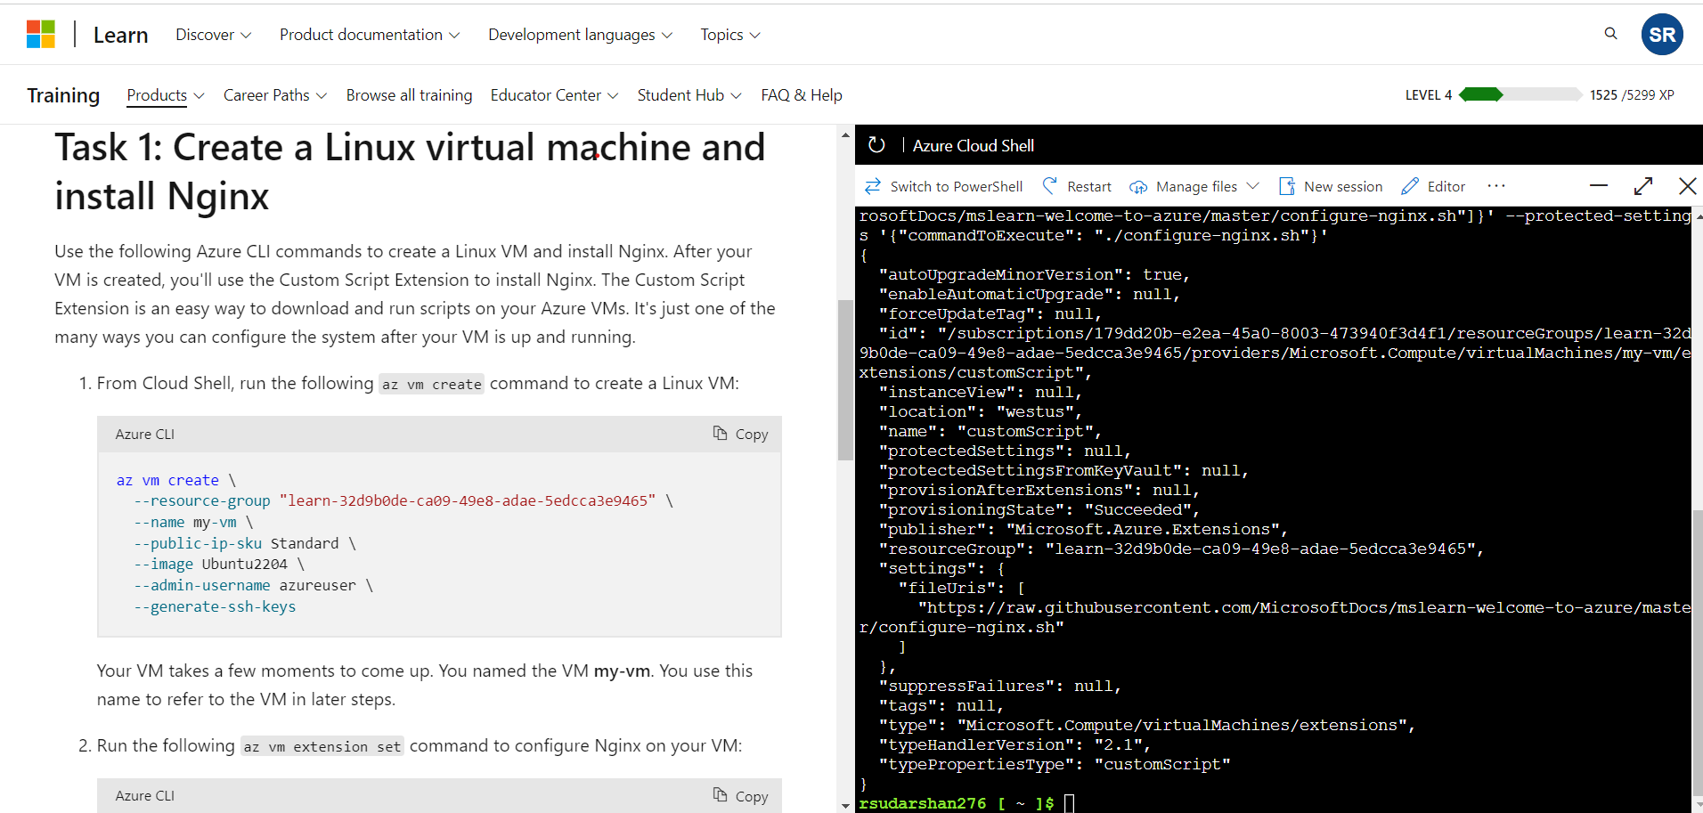

Access your web server

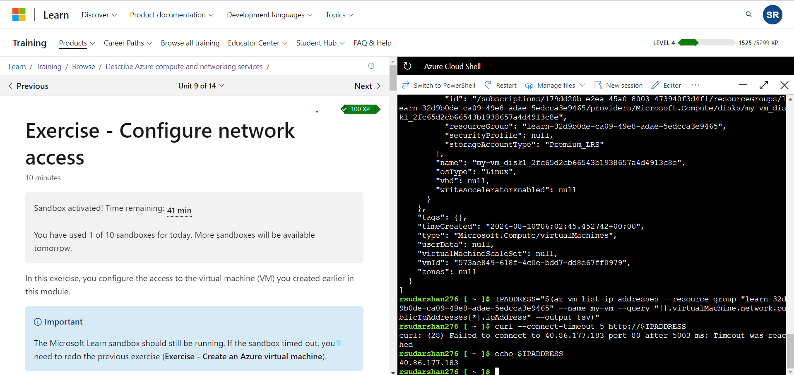

List the current network security group rules

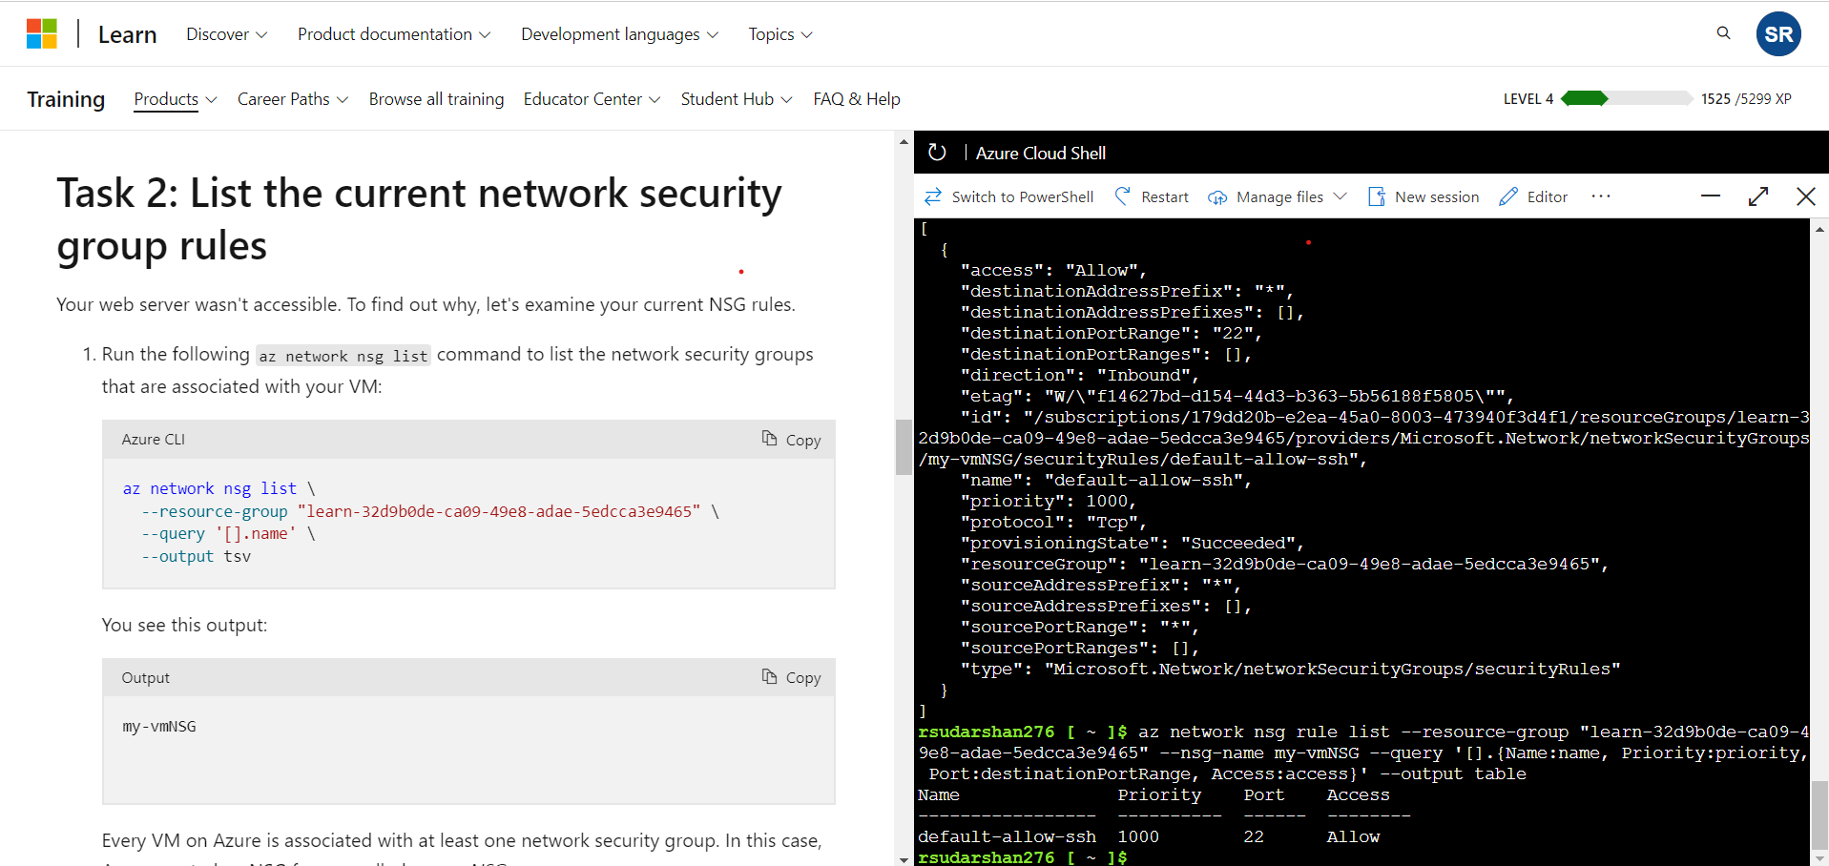

Create the network security rule

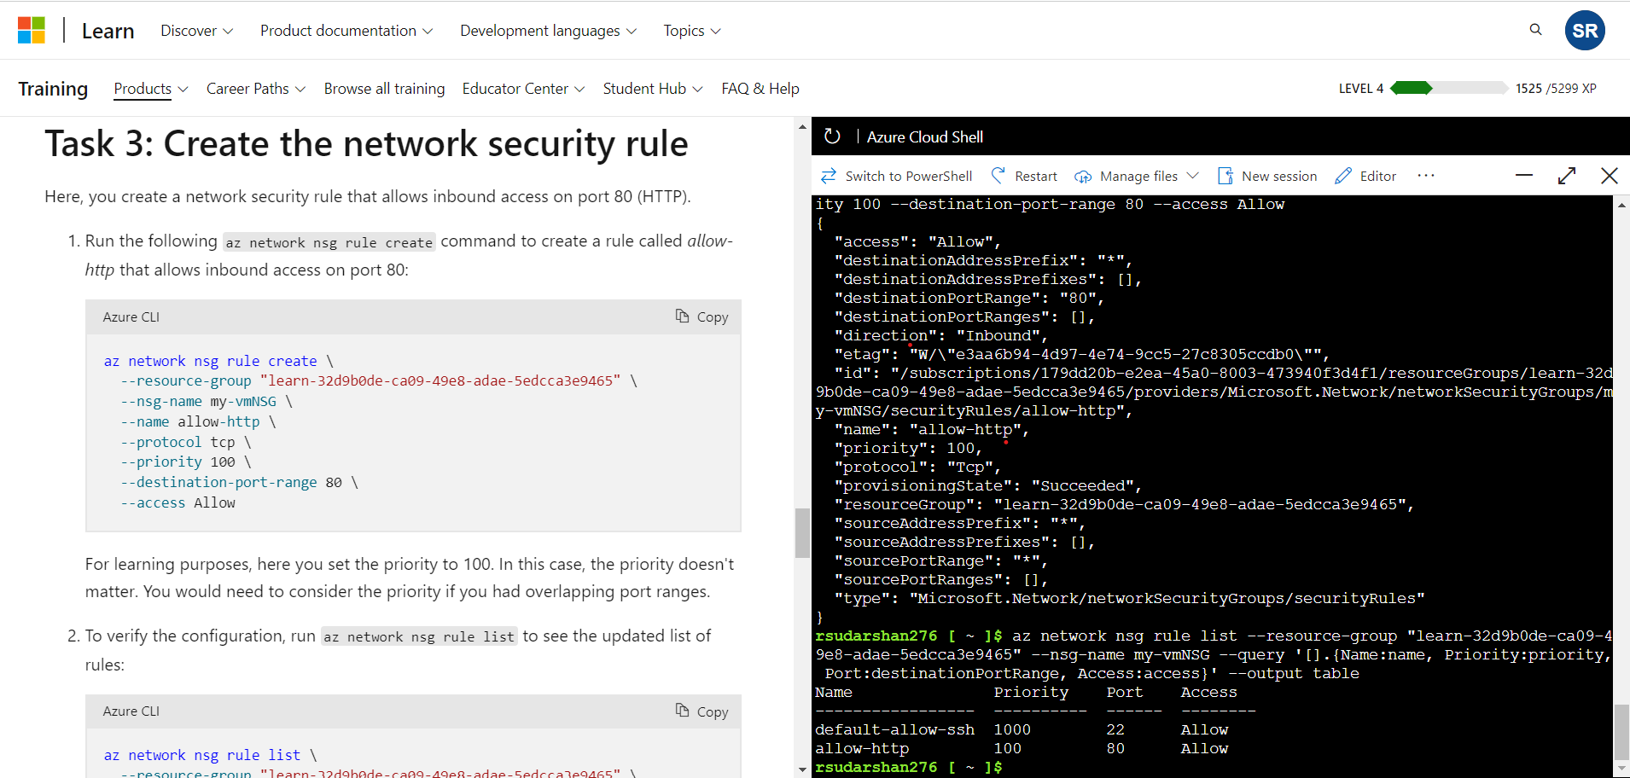

Access your web server again

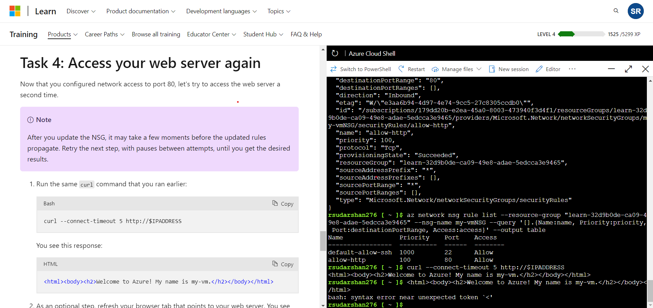

Final output:

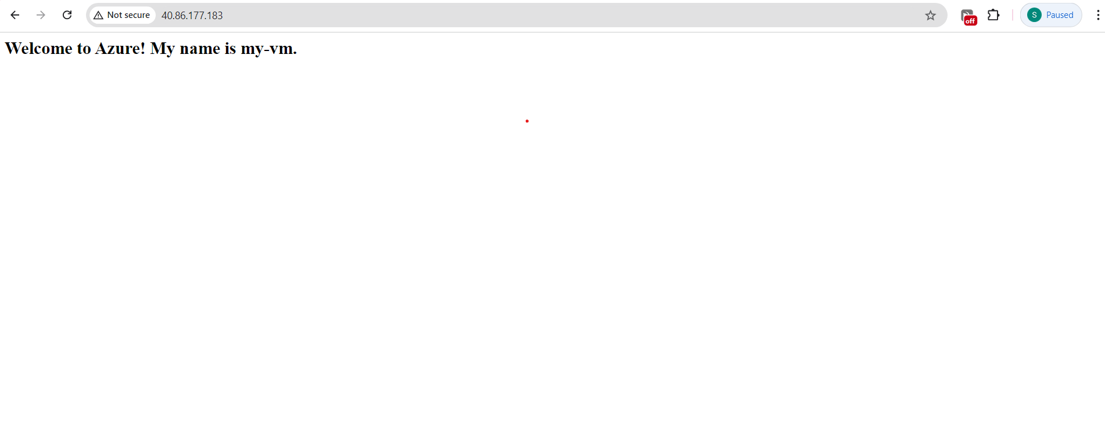

# Azure Academic Services: Azure for Students

Microsoft Academic Verfication Process

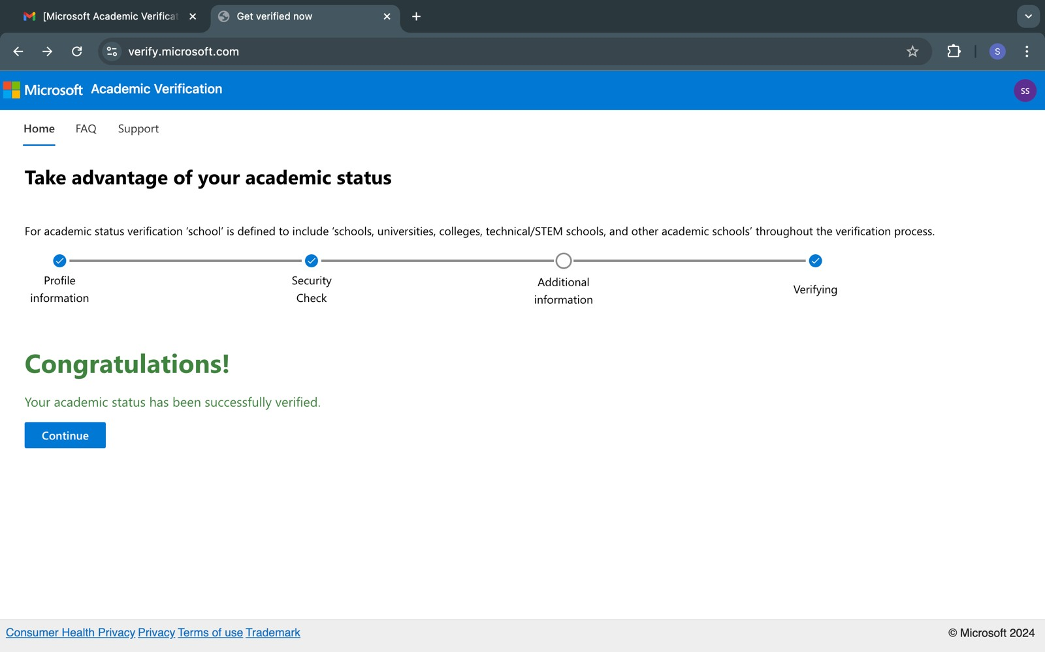

Creation of resource groups

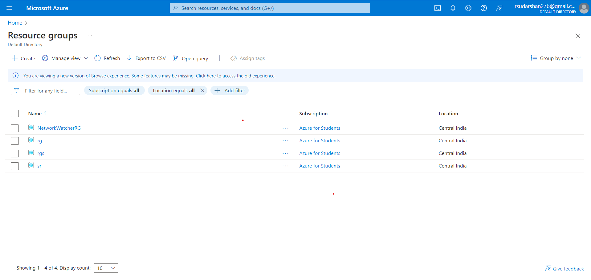

Creation of Virtual Machine

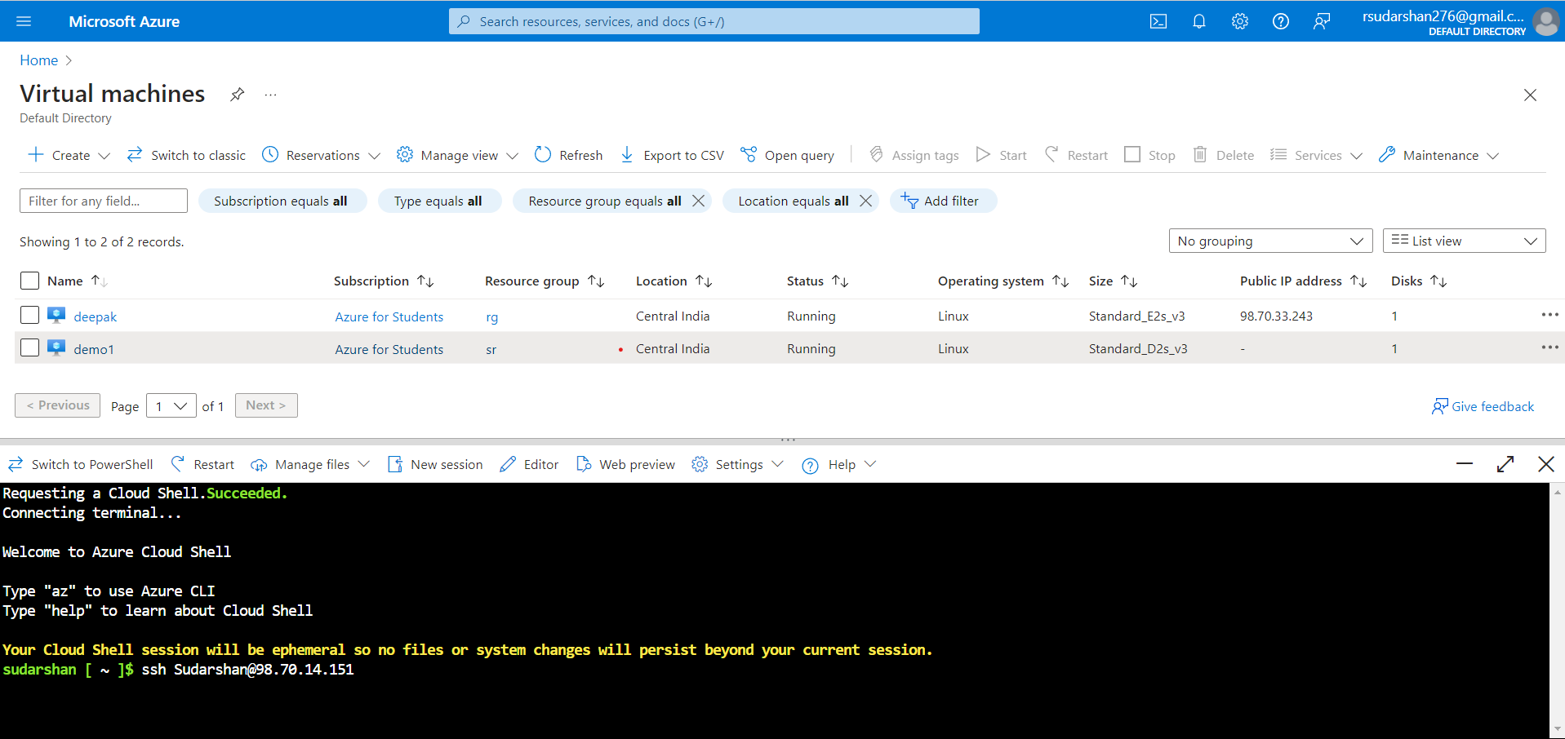

Hosting my portfolio using Azure Cloud Services

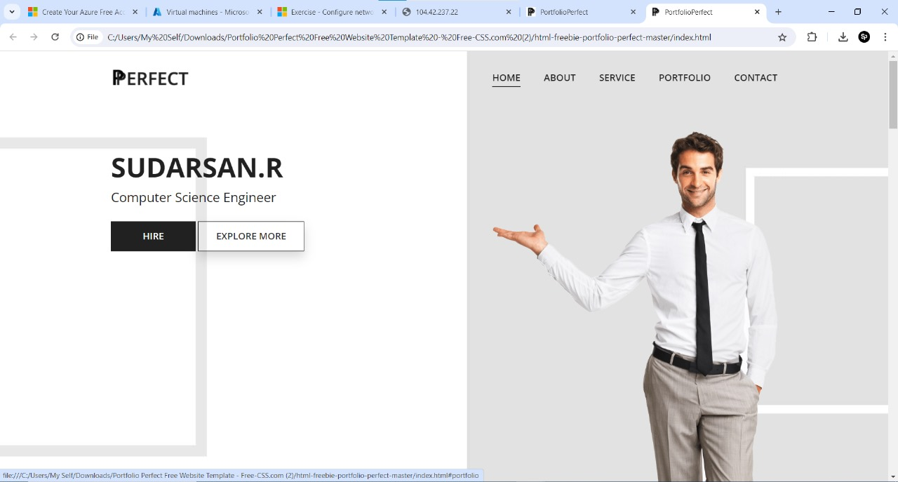

Pricing calculator

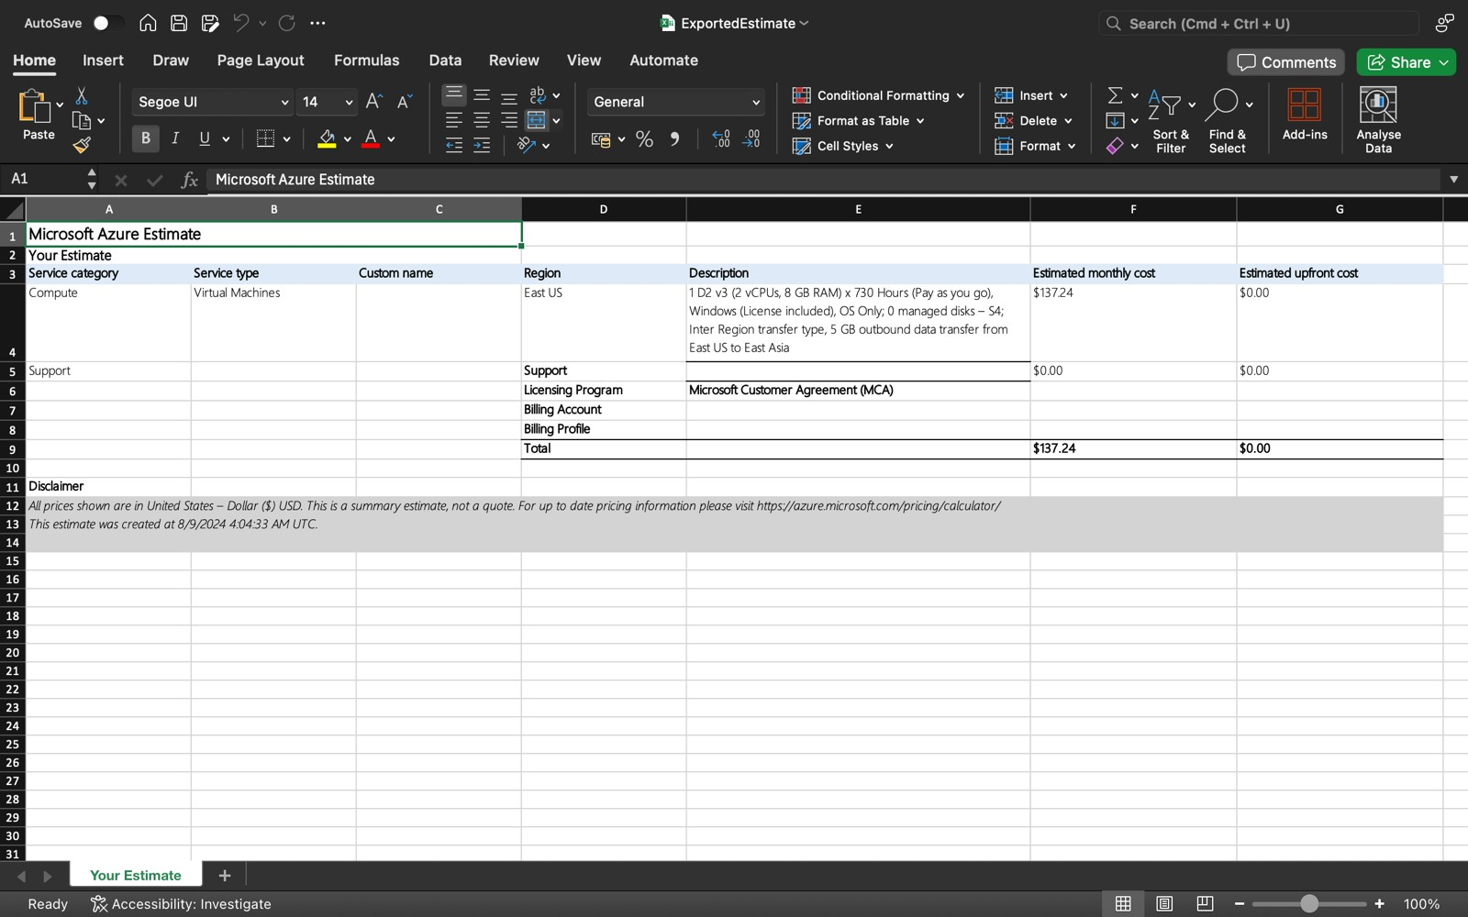

Total Cost of Ownership (TCO) Calculator

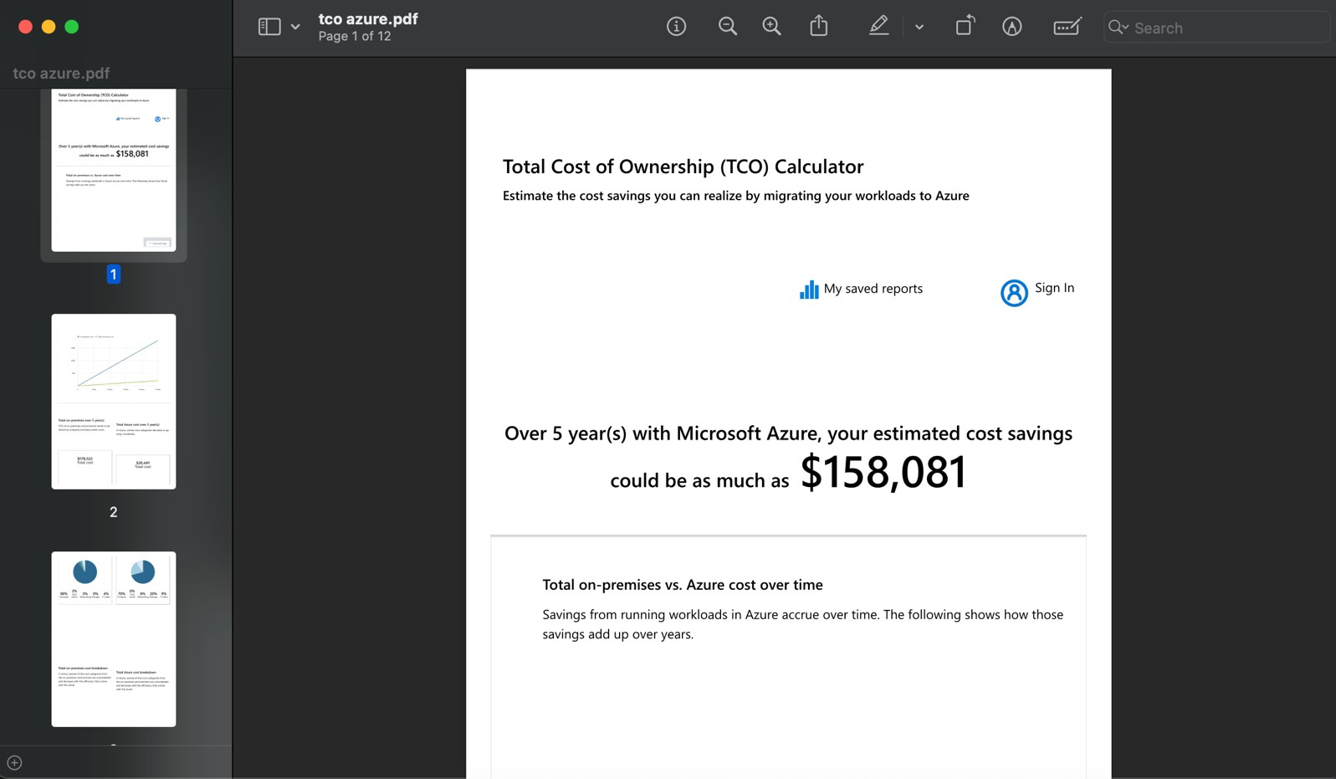

Creation of container

